Udai Solanki

Cloud10

Loyalty Management System

**Draft Ver 0.9 Dt – 16/Apr/2023**

**Cloud10 Loyalty Management System Technical Design**

Introduction

Cloud10 LMS (Loyalty Management System) is a platform that helps businesses to integrate, implement and manage their loyalty programs. It provides a centralized platform for tracking customer interactions, managing rewards and incentives, and analyzing customer behavior and preferences. The system is designed as a pluggable module for Channels or Booking Engines of the hospitality domain.

Features

This loyalty management system includes features such as:

* Customer Backend:
  + A decentralized customer backend on the Cardano blockchain can provide a secure and transparent way to store customer information, including their purchase history, loyalty program status.
  + Transaction records can be stored on the blockchain to maintain an immutable history of each customer's purchases, enabling retailers to provide personalized offers and recommendations based on their purchase history.
  + The use of smart contracts on the Cardano blockchain can enable retailers to implement loyalty programs that can automatically reward customers based on their purchases and other predetermined criteria.
  + With Cardano's high level of security, customers can be assured that their personal data is protected and cannot be tampered with or hacked.
  + Overall, a decentralized customer backend on the Cardano blockchain can offer numerous benefits for retailers and customers, including increased transparency, security, and personalized experiences.
* Rewards management: A module for managing rewards and incentives, such as points, discounts, free products, or exclusive offers.
* Customer Engagement: Tools for engaging customers, such as targeted messaging, personalized recommendations, and social media integrations.
* Analytics and reporting: A dashboard that provides insights into customer behavior, program performance, and ROI.
* Administration and security: Tools for managing program rules, settings, and access levels, as well as ensuring compliance with data protection regulations.

**Automation and Autonomous**

This system once integrated will work as an autonomous component once received the reservation data from the booking engine. Also by using a loyalty management system, businesses can automate many complex processes involved in managing a loyalty program, saving time and resources while providing a better customer experience. They can also use the data and insights generated by the system to optimize their program, improve customer engagement, and drive revenue growth.

High-Level Technical Specification

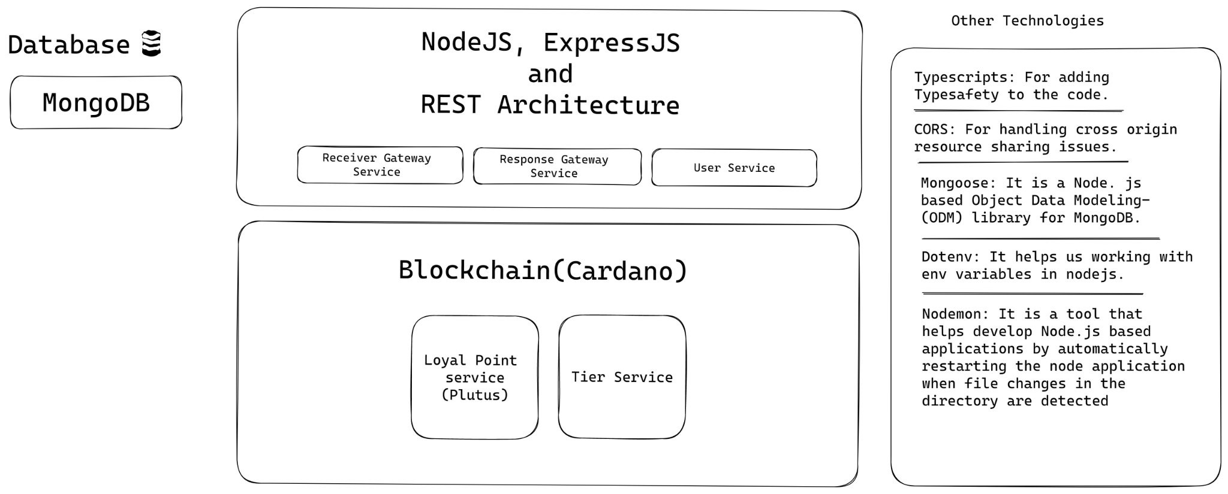

Different Modules

Welcome to Cloud10 Loyalty Management System, a comprehensive platform designed to help you build lasting relationships with your customers through personalized rewards and experiences.

The system is equipped with four key modules: Integration, Users, Manager, Admin, AI, and Recommendation. Each module is dealing with its own unique features and benefits.

For the first phase of the development, the AI and Recommendation modules are out of scope.

**Integration Module**

The integration module allows seamless integration with hotel owners, ensuring that your loyalty program is integrated into the hotel's reservation and payment systems. This module helps to create a smooth and effortless experience for your customers, enabling them to earn rewards seamlessly through their hotel bookings and transactions.

**JSON for the Integration Module:**

|  |  |
| --- | --- |
| Name | Data |
| Reservation Data |  |
| Users’ Data |  |
| Tiers’ Data |  |
| Points’ Data |  |

**Technical Design Diagram for Integration Module**

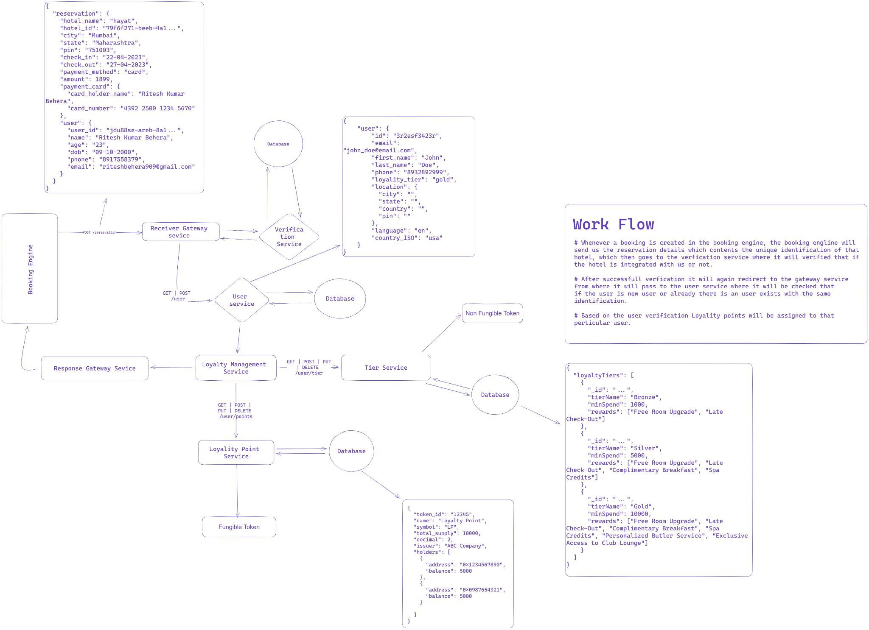

**Users Module**

The Users module provides a personalized experience for your customers, where they can track their loyalty program status, points balance, rewards, and other program-related information. This module allows your customers to feel more connected to your brand and keep track of their progress towards rewards and other incentives.

**Technical Design Diagram for User Module** 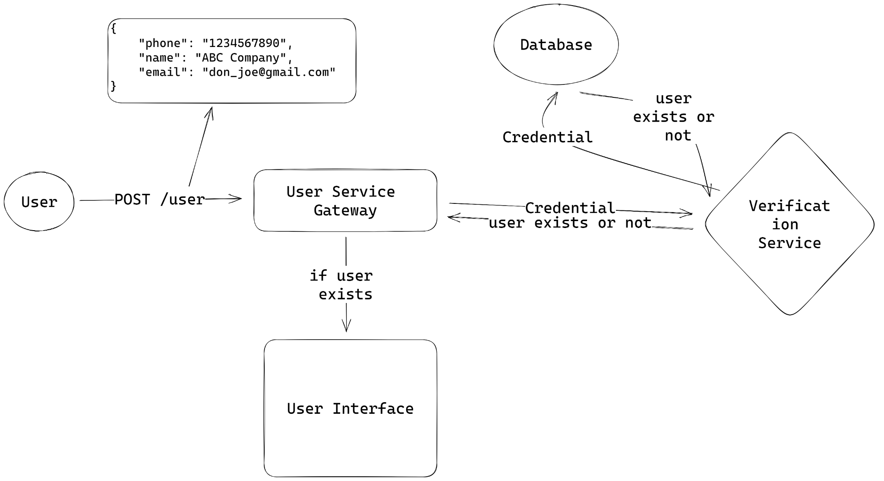

**Manager Module**

The manager module gives your team the ability to manage the loyalty program and interact with your customers more effectively. You can set up different tiers and rules for your loyalty program, track customer behavior, and reward your customers based on their activity. You can also create personalized offers and promotions that drive customer engagement and loyalty.

**Technical Design Diagram for Manager Module** 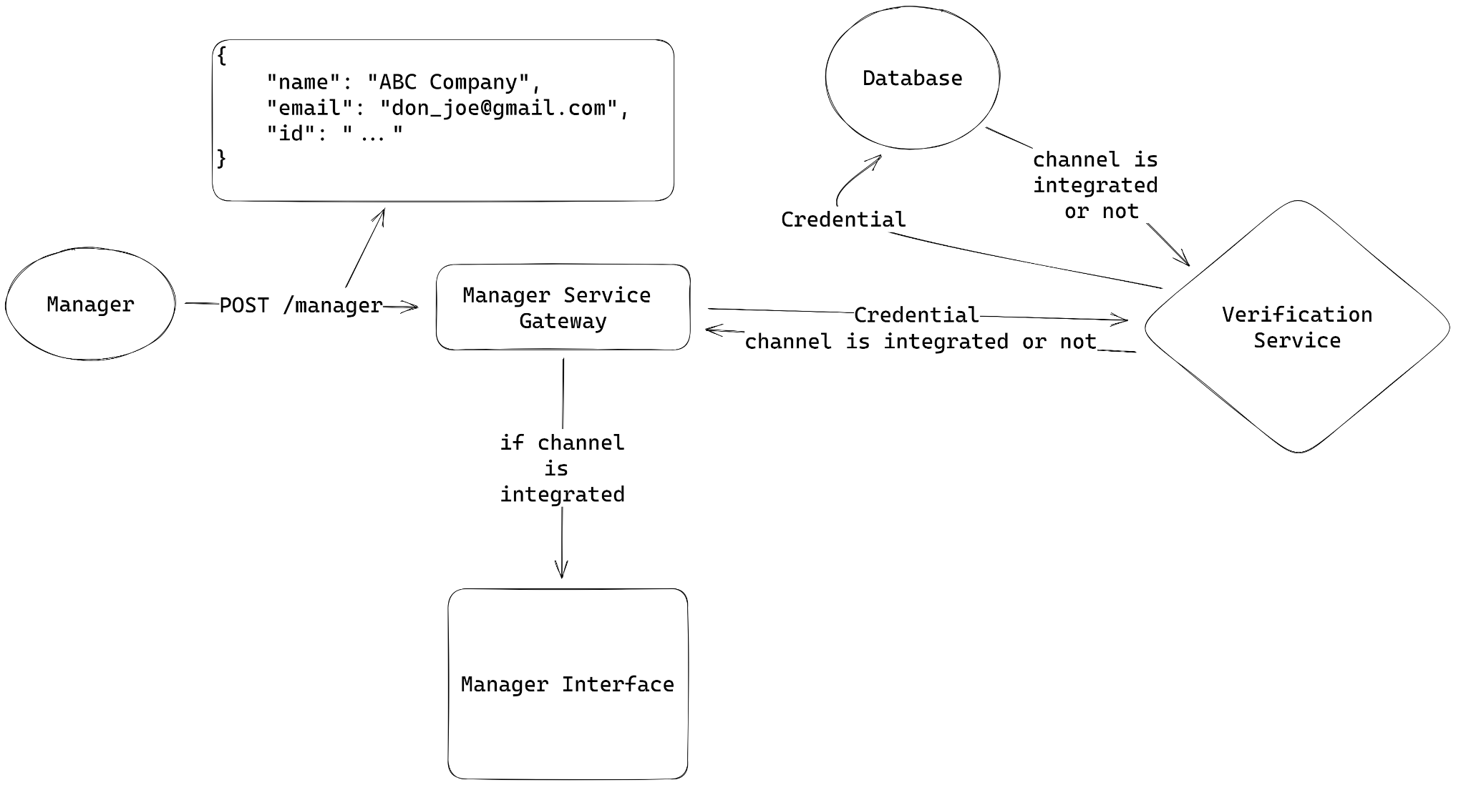

**Admin Module**

The Admin module is designed for super administrators who have full control over the entire loyalty program. You can manage users, rewards, and settings with ease. You can also generate reports to analyze program performance, customer behavior, and other key metrics. This module gives you the power to make data-driven decisions to optimize your loyalty program for maximum effectiveness.

**Technical Design Diagram for Admin Module**

